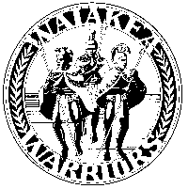
Waiākea High School Senior Project
155 West Kawili Street
Hilo, HI 96720

Phone (808)974-4888 Fax (808)974-4880

Thank You Letter Format

Your community mentor is an important part of your success in the Senior Project. It is important that you formally thank them even if you have verbally done so. Also, remember that writing a thank you letter to your community mentor is very important to the success of our Senior Project program.
- Write your letter and prepare an envelope before the conclusion of your Internship or project.
- Give the envelope with your thank you letter to your mentor on your last day.
- If you have already completed your internship, mail the letter to your mentor.
- You must include a copy of the letter in your portfolio.
- Be sure to include the following in your letter.

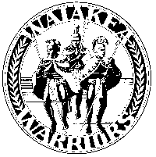

January 1, 2014

Mentor Name
Company Name
4321 Their Avenue
Hilo, Hawaii 96720

Dear __________:

(First Paragraph)
Explain the purpose of your letter, i.e. why you are thanking your mentor. Express your thanks simply and directly. Include a line or two to say specifically what you appreciated about your mentor; a special quality, feature, example, or action would be appropriate.

(Second Paragraph)
You should end the letter with a general statement about how the internship helped you. Thank them, again.

Sincerely,

Signature (put 4 spaces between sincerely and your printed name).

Typed Student Name

Waiakea High School Senior Project
155 West Kawili Street
Hilo, Hawaii 96720
808.974.4888

